SCHOOL OF COMPUTER SCIENCE AND ARTIFICIAL INTELLIGENCE |  |  |  |  | DEPARTMENT OF COMPUTER SCIENCE ENGINEERING
Program Name: M. Tech/MCA/MSC |  |  |  | Assignment Type: Lab |  |  | AcademicYear:2025-2026
Course Coordinator Name |  |  |  | Venkataramana Veeramsetty
Course Code |  |  |  | Course Title |  | AI Assisted Problem Solving Using Python
Duration |  |  | 2 Hours | Applicable to  Batches
AssignmentNumber:12.3(Present assignment number) /24(Total number of assignments)
NAME: RIMSHA MUJEEB ROLLNUMBER:2503B05138(M.Tech-CSE)
 | Q. No. | Question
 | Q1.  Q2.  Q3. | Task Description #1 – Linear Search implementation  Task: Write python code for linear_search () function to search a value in a list and extract its index.  CODE:  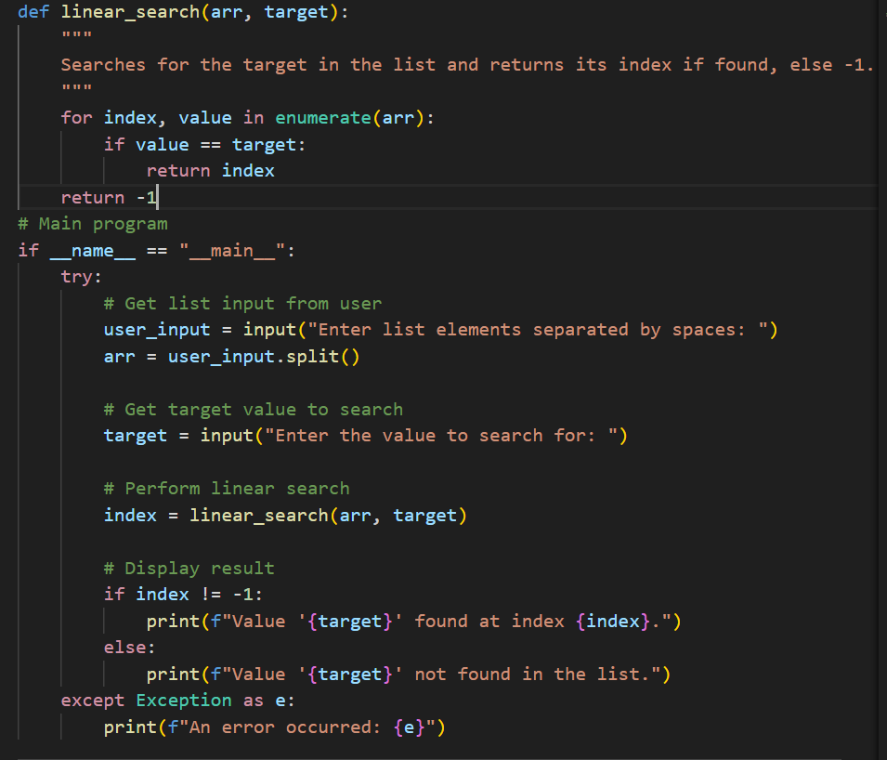  OUTPUT:  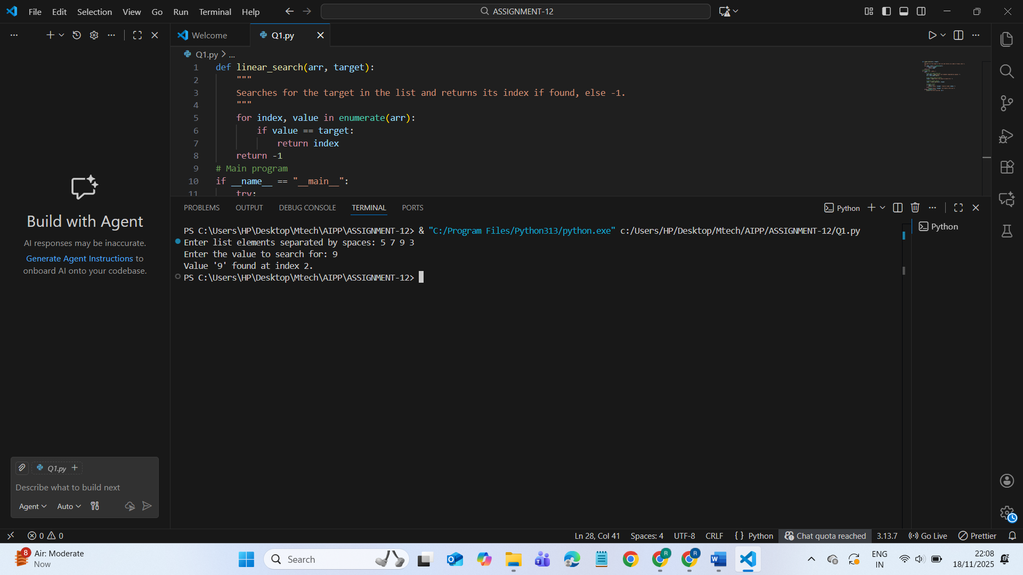  Task Description #2 – Sorting Algorithms  Task: Ask AI to implement Bubble Sort and check sorted output  CODE:  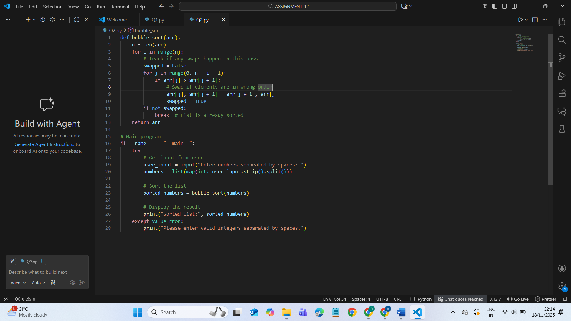  OUTPUT:  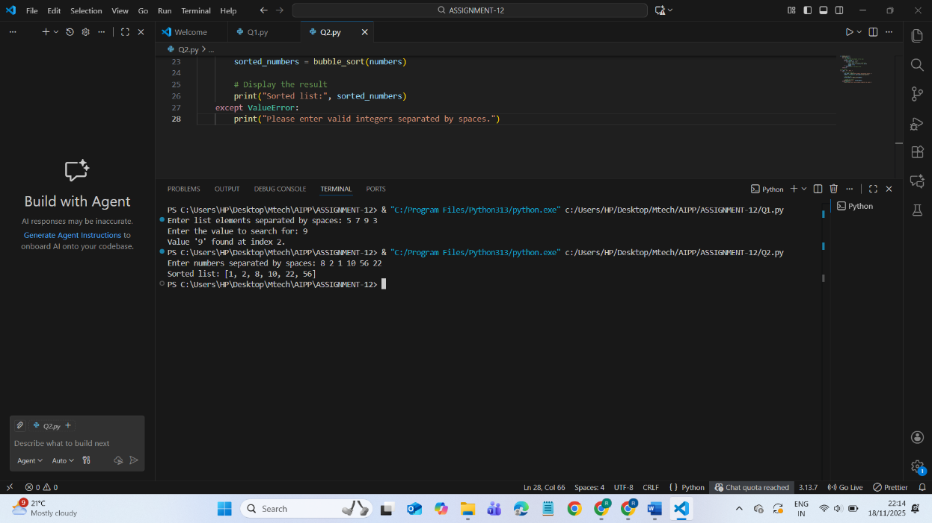  Task Description #3 – Optimization  Task: Write python code to solve below case study using linear optimization  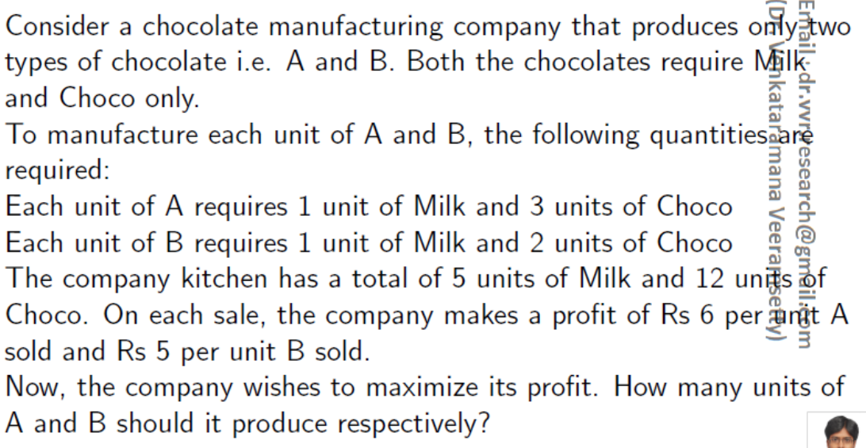  CODE:  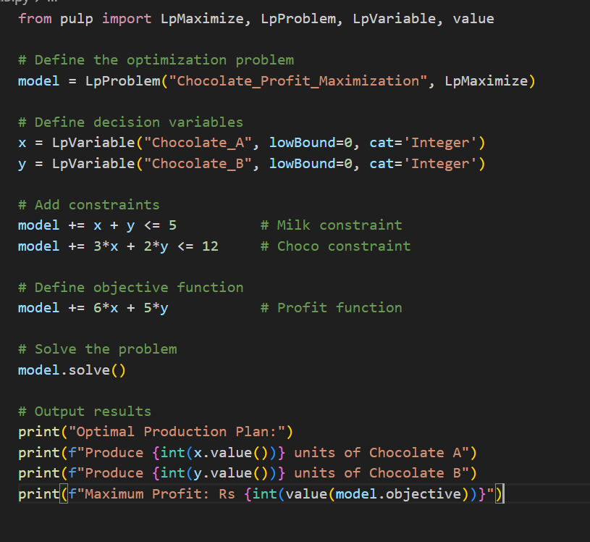  OUTPUT:  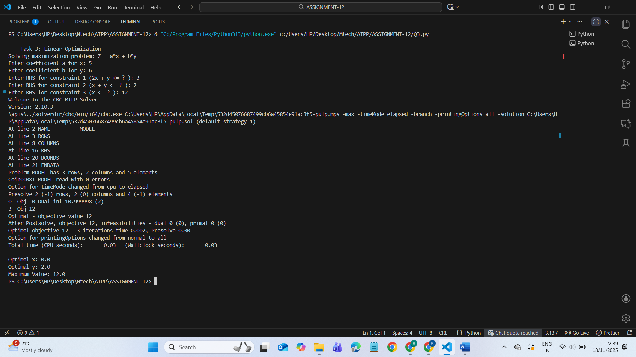  Task Description #4 – Gradient Descent Optimization  Task: Write python code to find value of x at which the function f(x)=2X³+4x+5 will be minimum  CODE:  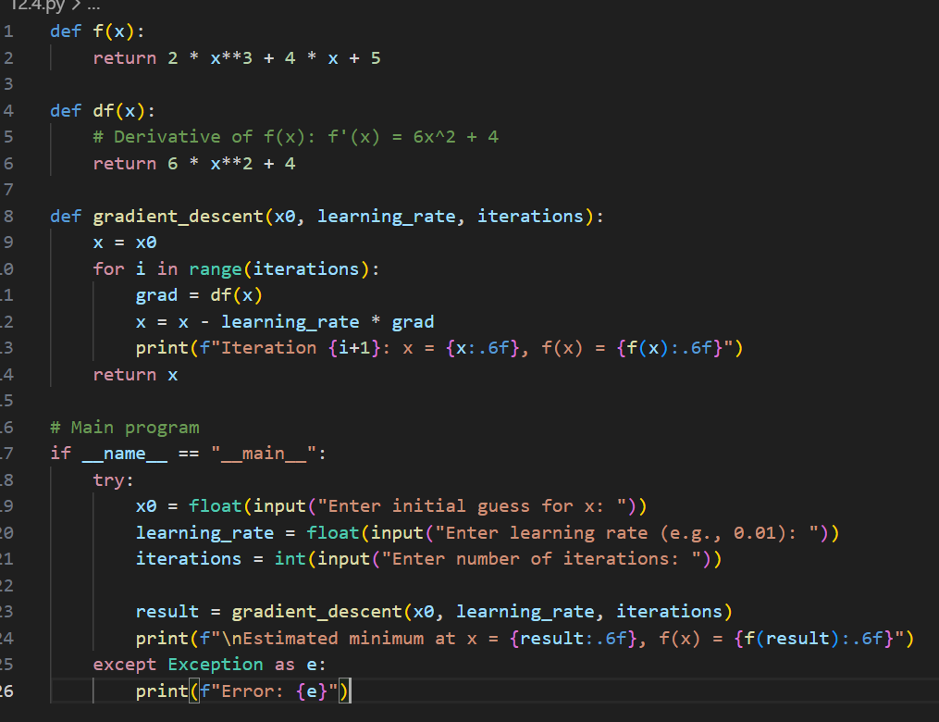  OUTPUT:  